EXPERIMENT-1 HEAT EQUATION USING MATLAB

**CODE:**

L=100;

N=100;

Dx=L/(N-1);

k=500;

T=zeros(N,1);

Tb=100;

for j=i:1:k

T(1,1)=Tb;

for i=2:1:(N-1)

T(i,1)=(T(i-1,1)+T(i+1))/2;

end

T(N,1)=T(N-1,1)

plot(T)

hold on

end

**GRAPH:**

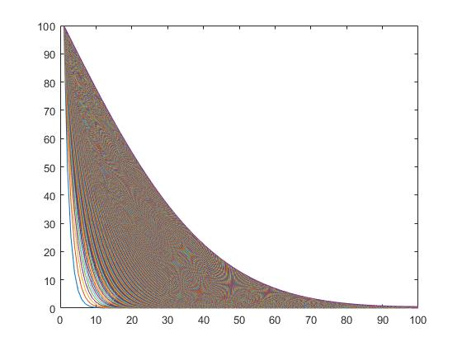

**SOLUTION:**

T =

100.0000

97.4775

94.9600

92.4501

89.9501

87.4626

84.9898

82.5341

80.0978

77.6831

75.2920

72.9268

70.5894

68.2816

66.0053

63.7623

61.5540

59.3822

57.2481

55.1532

53.0987

51.0856

49.1151

47.1879

45.3050

43.4670

41.6745

39.9280

38.2279

36.5745

34.9680

33.4085

31.8960

30.4303

29.0114

27.6391

26.3128

25.0324

23.7973

22.6069

21.4607

20.3581

19.2982

18.2804

17.3038

16.3677

15.4710

14.6129

13.7925

13.0088

12.2608

11.5475

10.8678

10.2208

9.6055

9.0206

8.4654

7.9386

7.4393

6.9664

6.5190

6.0960

5.6964

5.3193

4.9637

4.6288

4.3135

4.0170

3.7384

3.4769

3.2318

3.0021

2.7871

2.5861

2.3985

2.2234

2.0603

1.9086

1.7677

1.6369

1.5159

1.4040

1.3008

1.2059

1.1188

1.0392

0.9667

0.9010

0.8417

0.7887

0.7416

0.7002

0.6644

0.6340

0.6088

0.5888

0.5738

0.5639

0.5589

0.5589

T =

100.0000

97.4800

94.9651

92.4576

89.9601

87.4749

85.0045

82.5511

80.1171

77.7046

75.3157

72.9525

70.6171

68.3112

66.0367

63.7954

61.5888

59.4185

57.2858

55.1923

53.1389

51.1270

49.1575

47.2312

45.3491

43.5118

41.7199

39.9739

38.2742

36.6211

35.0148

33.4554

31.9429

30.4771

29.0581

27.6855

26.3589

25.0781

23.8425

22.6516

21.5049

20.4015

19.3410

18.3224

17.3450

16.4080

15.5105

14.6515

13.8302

13.0455

12.2965

11.5822

10.9015

10.2535

9.6371

9.0512

8.4949

7.9671

7.4668

6.9929

6.5444

6.1204

5.7199

5.3418

4.9853

4.6494

4.3332

4.0358

3.7564

3.4941

3.2481

3.0176

2.8018

2.6001

2.4118

2.2361

2.0723

1.9200

1.7785

1.6472

1.5256

1.4132

1.3096

1.2142

1.1267

1.0467

0.9739

0.9078

0.8482

0.7949

0.7476

0.7060

0.6700

0.6394

0.6141

0.5940

0.5789

0.5689

0.5639

0.5639

**EXPERIMENT-2 ONE DIMENSIONAL HEAT TRANSFER IN A FIN**

**CODE:**

clc;

clear;

L=10;

Tb=1200;

Ta=300;

gridpoints=101;

steps=100000;

dx=L/(gridpoints-1);

X=0:dx:L;

T=zeros(1,gridpoints);

for j=1:1:steps

T(1)=Tb;

T(gridpoints)=Ta;

for i=2:1:gridpoints-1

T(i)=(T(i+1)+T(i-1))/2;

end

end

plot(X,T)

xlabel('Length of fin (m)');

ylabel('Length of fin (k)');

**GRAPH:** 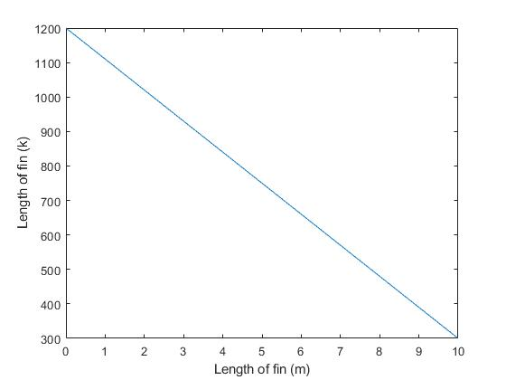

EXP:3 TEMPERATURE PLOT OF A FIN

**CODE:**

L = input('Enter their length of the fin LL=\n');

D = input('Enter the diameter of the fin :D=\n');

Tb = input('Enter the base temperature of the fin :Tb=\n');

Ta = input('Enter the ambient temperature of the fin :Ta=\n');

K = input('Enter the thermal conductivity of the fin :K=\n');

H = input('Enter the convective heat transfer co-efficient of the fin :H=\n');

syms Theta(x)

Dy = diff(Theta,x,1);

cond = [Theta(0)==(Tb-Ta),Dy(L)==0];

p =(pi*D);

A = (pi*D^2)/4;

m = sqrt(H*p/(K*A));

eqn = diff(Theta,x,2)-((m^2)*Theta);

Theta = dsolve(eqn,cond);

TL = ((Tb-Ta)*(1/cosh(m*L)))+(Ta);

Pretty (Theta)

Fplot (Theta,[0,L])

grid on

title ('Temperature Distribution');

xlabel('Length of the fin(in meters)');

ylabel('Temperature (in degree centigrade)');

**INPUT VALUES:**

Enter their length of he fin:L=

0.25

Enter the diameter of the fin:=

0.02

Enter the base temperature of the fin:Tb=

100

Enter the ambient temperature of the fin:Ta=

30

Enter the thermal conductivity of the fin:K=

330

Enter the convective heat transfer co-efficient of the fin:H=

7

**SOLUTION :**

Dy(x) =

diff(Theta(x), x)

cond =

[Theta(0) == 70, subs(diff(Theta(x), x), x, 1/4) == 0]

p =

0.0628

A =

3.1416e-04

m =

2.0597

eqn(x) =

diff(Theta(x), x, x) - (140*Theta(x))/33

Theta =

(70*exp(-(2*1155^(1/2)*x)/33)*(exp(1155^(1/2)/33) + exp((4*1155^(1/2)*x)/33)))/(exp(1155^(1/2)/33) + 1)

Tl =

91.6452

/ 2 sqrt(1155) x \ / / sqrt(1155) \ / 4 sqrt(1155) x \ \

exp| - -------------- | | exp| ---------- | + exp| -------------- | | 70

\ 33 / \ \ 33 / \ 33 / /

------------------------------------------------------------------------

/ sqrt(1155) \

exp| ---------- | + 1

\ 33 /

**GRAPH :** 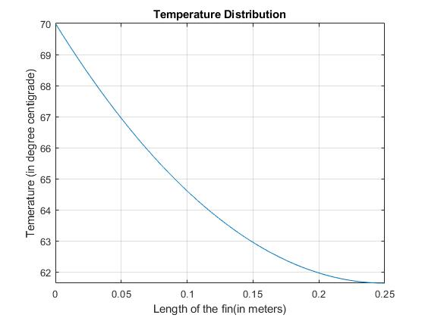

*EXP:4* FOURIER LAW OF HEAT CONDUCTION

CODE:

L = input ("Enter the length of the wall: L=\n");

H = input ("Enter the height of the wall: H=\n");

t = input ("Enter the thickness of the wall: t=\n");

T1 = input ("Enter the temperature at the enter of the wall: T1=\n");

T2 = input "Enter the temperature at the exit of the wall: T2=\n");

K = input ("Enter the thermal conductivity at the wall of the material: K=\n");

A = (L*H);

Q = (((K*A)*(T1-T2))/t);

syms T(x)

T(0)==T1

T(t)==T2

cond = [T(0)==T1,T(t)==T2];

eqn = diff(T,x,1)+(Q/(K*A))

T = dsolve(eqn,cond)

x = input ("Enter the thickness of x from the wall:x=\n");

Tx = (T1-(Q*x/(K*A)))

pretty(T)

fplot(T,[0,t])

grid on

title("Temperature Distribution");

xlabel("Thickness of the brick wall(in meters)");

ylabel("temperature (in degree)");

INPUT VALUES:

Enter the length of the wall: L=

1

Enter the height of the wall: H=

1

Enter the thickness of the wall: t=

5

Enter the temperature at the enter of the wall: T1=

50

Enter the temperature at the exit of the wall: T2=

20

Enter the thermal conductivity at the wall of the material: T1=

300

SOLUION:

ans =

T(0) == 50

ans =

T(5) == 20

eqn(x) =

diff(T(x), x) + 6

T =

50 - 6*x

Enter the thickness of x from the wall: x=

0.25

Tx =

48.5000

50 - 6 x

>>

GRAPH:

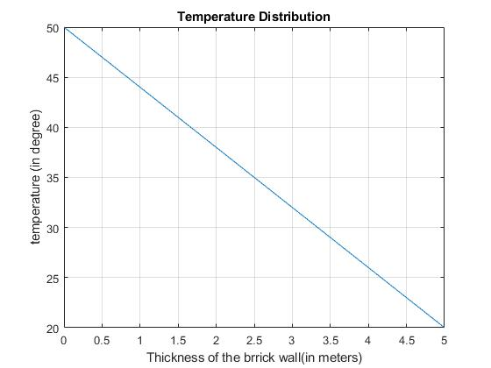

EXP:5 STEADY STATE 2 DIMENSIONAL HEAT TRANSFER

CODE:

nw = 51;

nh = 31;

w=5;

h=3;

x=linspace(0,w,nw);

y=linspace(0,h,nh);

T=zeros(nh,nw);

T(1,1:nw)=500;

T(nh,1:nw)=500;

T(1:nh,1)=1000;

T(1:nh,nw)=200;

tol=0.1;

error=1;

while error>tol

T_old=T;

for i=2:1:nh-1

for j=2:1:nw-1

T(i,j)=0.25*(T(i,j-1)+T(i-1,j)+T(i+1,j)+T(i,j+1));

end

error=max(max(abs(T_old-T)));

end

end

subplot(2,1,1),pcolor(x,y,T),shading interp,

title('Temperature(steady state)')

xlabel('x(m)'),ylabel('y(m)'),colorbar

subplot(2,1,2),contour(x,y,T),colormap('jet')

title('Temperature(steady state)')

xlabel('x(m)'),ylabel('y(m)'),colorbar

GRAPH:

